Creating a Resume using Google Docs

Step #1: Log into Google using a gmail address
- If you do not have a google email, I would suggest creating one using only things associated with your name
- Do not include things such as your graduation year, social security #, or birthdate
- Avoid any usernames that showcase your personality

Step #2: Go to your Google Drive & click on New Google Docs
Step #3: Once a blank document opens, go to File Menu From Template

Step #4: Visit the Template Gallery & Scroll to find Resumes. Choose one of the four resume templates.
Step #5: Double Click on the Template you have chosen so that it opens. Rename the Resume as your full name resume. Example: John Adams Resume
Step #6: Share the resume with mlshaffer@clarkston.k12.mi.us
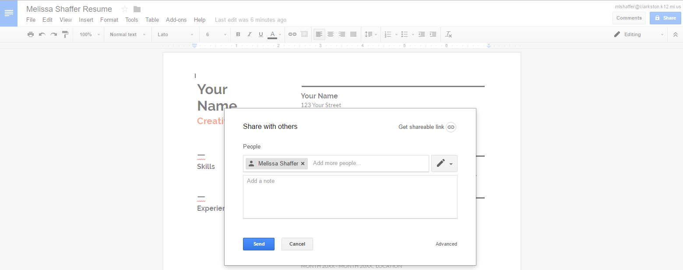

Creating the Resume
Step #7: Replace Your Name with your Legal Name (Name that matches your Driver’s License / Social Security Card
Step #8: Delete the Job Title
Step #9: Change Contact Information so that it matches your current contact information (Mailing, Phone, & Email)
- If you have a home phone & a cell phone list both

Step #10: Scroll to Education & Complete it based on the classes, grades, & extracurricular involvement you have
participated in at Renaissance High School
- If you have attended multiple high schools list your previous school prior to Renaissance. Do not include more than two if you have attended three or more.
- Delete the second education field if it does not apply to you or you not wish to use it
- If you attended multiple schools but do not wish to list anything other than Renaissance, put Class of 2017 instead of a range of dates

Step #11: Complete Experience Section for any employment experience you may have
- Use consistent verb endings (words end in -ed if previous job)
- Should have at least three bullet points explaining job activities
- Use quantifiable information when possible
Step #12: Complete Skills Section
- Do you speak, read, and/or write multiple languages?
- What computer programs do you know? (Microsoft Word & PowerPoint are standard)
- Trade Skills: Car, Manufacturing, Construction, etc..
- Office Skills: Answer phones, make copies, send a fax, Type 50 words or more a minute, alphabetize
- Sports & Athletic ability is not a skill

Step #13: Complete Summary of Qualifications
- Consists of 4-6 of your strongest selling points
- Used when you don’t have a set objective statement

Step #14 List any Awards you have won
- Employee
- Student
- Athletic
- Volunteer

Step #15 List 3 – 5 References on the back side of your template
- Full Name
- Relationship to you
- Mailing Address
- Phone Number
- Email

Goals for your resume:
- A good resume will be one, full page in length
- Normal font type and font size (11 or 12) should be used
- When you have a bullet listed, there should be at LEAST TWO Bullets
- Use consistent action verb endings
- All Information provided is positive in nature
- All information is accurate
- Proofread your resume so it contains no errors
- All formatting should be consistent. Bullets, dates, headings all start in same place
- Don’t include pictures
- Print on white or ivory colored paper

